SOLENOID VALVE

OFF

SENSOR 2

LIQUID FILLS UP TANK

SOLENOID VALVE ON

SENSOR 1

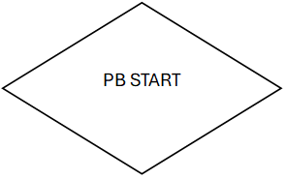

ON

MOTOR OFF

MOTOR ON

LIMIT SWITCH

PB STOP